Database Design Report

Group Members:

Alonzo Contreras

Marcus Mertillien

Matt Ho

Betty Reaney

Our database is off a game design where you have two players have squads of different units that each have different health, movement, range, defense, abilities, and speed. On the map each unit can be placed or move to depending if it's the start or the middle of the match. The game also has a login feature that takes in a players email, username and password. Then that player will have a designated id.

**Requirements analysis:**

What is going to be stored?

Our database will be storing players login information (email, username, and password),

Will also store what unit types and their position on the board.

What are we going to do with the data?

We are going to use the data to store information from the game and use it to update both players of the game

Who should access the data?

Only the admings of the game as well as the players playing in the game should be able to access the data indirectly

**Conceptual Design:**

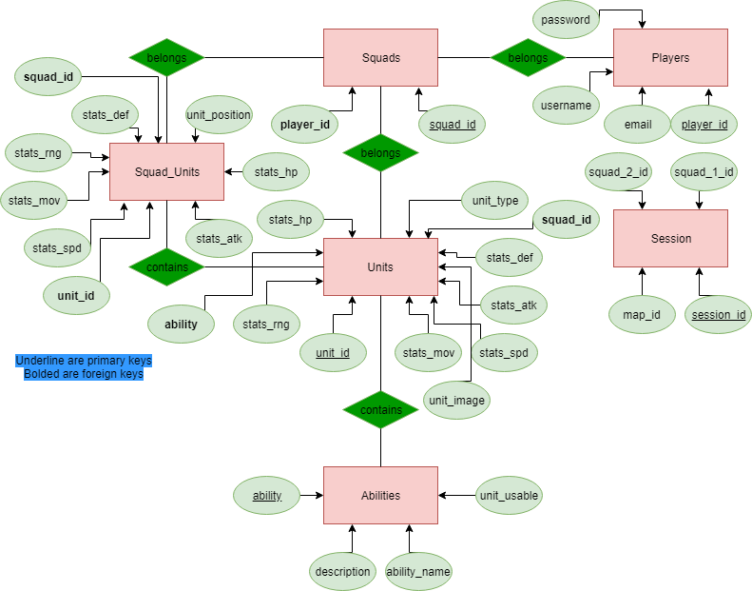

**Logical Schema:**

Squad_Unit(unit_position: point, stats_hp: int, stats_mov: int, stats_spd: int, stats_def: int, squad_id: int, unit_id: int)

Abilities(ability: int, description: varchar, unit_usable: boolean, ability_name: varchar)

Squads(squad_id: int, player_id: int)

Units(unit_id: int, unit_type: varchar, stats_hp: int, stats_mov: int, stats_spd: int, stats_atk: int, stats_def: int, stats_rng: int, unit_image: varchar, squad_id: int, ability: int)

Players(player_id: int, email: varchar, username: char, password: text)

Session(session_id: int, map_id: int, squad_1_id: int, squad_2_id: int)